January – December 2025 Calendar

We will notify all parents/guardians in advance of any changes.
Wednesday, January 1, 2025 |  New Year’s Day Observed - Closed
Monday, January 20 |  Dr. Martin Luther King Jr. Day - Closed
Monday, February 17 |  President’s Day - Closed
Friday, April 18 |  Good Friday – Closed
Monday, May 26 |  Memorial Day – Closed
Thursday, June 19 | 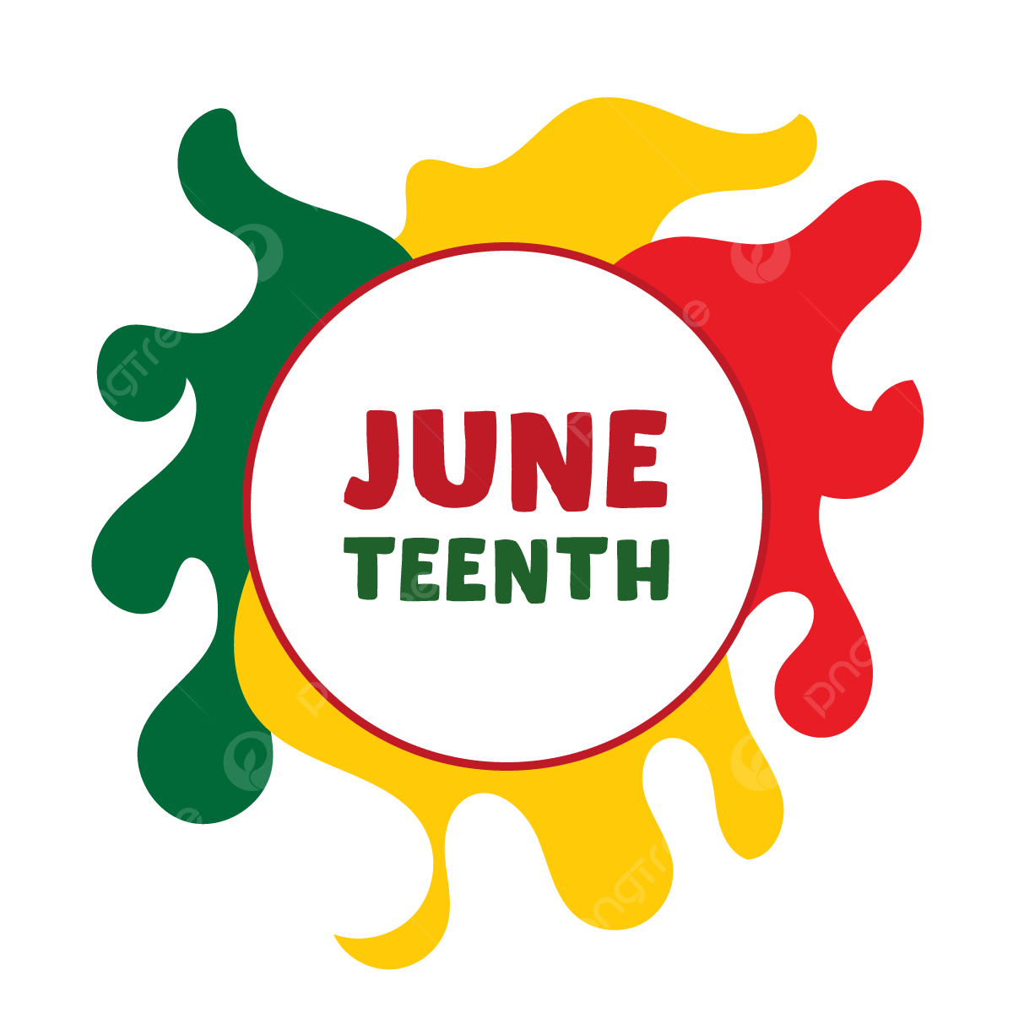 Juneteenth - Closed
Friday, July 4 |  Independence Day - Closed
Thursday, August 28* |   Staff Professional Development- *Closing at 5 pm
Friday, August 29 |   New School Year Preparations- Closed
Monday, September 1 |  Labor Day - Closed
Tuesday, September 23  Wednesday, September 24 |  *Rosh Hashanah – Closed
Thursday, October 2 |  Yom Kippur - Closed
Monday, October 13 |  Italian Heritage / Columbus Day - Closed
Tuesday, November 11 |  Veteran’s Day - Closed
Thursday, November 27  Friday, November 28 | 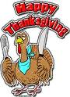 Thanksgiving Holiday - Closed
Wednesday, December 24  Thursday, December 25  Friday, December 26 |  24th- Christmas Eve- Closed  25th - Christmas Day- Closed  26th - Winter Break Closed
Wednesday, December 31 |   New Years Eve - Closed
Revised: December 10, 2024

